Lab 10: Momentum
Name: Farooq Ahmodu
PSY 2001
Objective:
To determine whether elastic collisions obey the law of conservation of momentum.

Procedure:
Virtual simulation: https://www.physicsclassroom.com/Physics-Interactives/Momentum-and-Collisions/Collision-Carts/Collision-Carts-Interactive

- Select “Elastic collision”
- Conduct trials for the following:
Initial velocities of 5 m/s for both cars (note: you must account for direction (+/-) in your calculations since velocity is a vector)
- m₁=1kg, m₂=1kg
- m₁=1kg, m₂=2kg
- m₁=2kg, m₂=3kg
Note: click “start” on the right corner to begin the experiment
- Find % difference.

Theory:

- Momentum: the linear momentum p of an object of mass m moving with velocity v is the product of its mass and velocity.
p=mv

- Conservation of momentum: when no net external forces act on the system, the total momentum of the system remains constant in time.
$\vec{F}$_{net}=0
Δ$\vec{p}$=0
$\vec{p}$=$\vec{p}$’
m₁$\vec{v}$₁+ m₂$\vec{v}$₂= m₁$\vec{v}’$₁₊ m₂$\vec{v}$’₂

where p – initial momentum, p’ – final momentum, v – initial velocity, v’ – final velocity.
Conservation of energy and momentum plays an important role in fundamental symmetries of physical nature. In this experiment, we analyzed and tested how conservation of momentum occur during collision processes,
Momentum is the product of mass and velocity of a given particle;
p = m v
Momentum is associated with motion of an object and therefore, it is a vector quantity hence, direction is a necessary part of the momentum. Momentum is defined in three-dimensional spaces, x, y and z and the momentum of system of more than one particle is the vector sum of individual momenta.
P₁ +P₂ +P₃ ………. = m₁ v₁ + m₂ v₂ + m₃v₃
According to 2nd Newton’s law of motion, the rate of change in momentum of a system equals to the sum of external forces acting on a system and the energy associated with change in momentum is kinetic energy. The kinetic energy is the form associated with motion of particle and is expressed as:
KE = $\frac{Mv^{2}}{2}$
Collisions plays an important part in testing the application of conservation of momentum, it is hard to assess how collision of bodies interact with each other but with a closed system conservation laws are easy to assess especially in elastic collisions.
Conservation of momentum states that the total momentum before collisions should be equal to total energy after collision i.e.
P_{i} = m_{1i} v_{1i} + m_{2i} v_{2i}
P_{f} = m_{1f} v_{1f} + m_{2f} v_{2f}
P_{i =} P_{f}
In an Elastic collision, when two bodies come together, collide and move apart, there is no loss in the total kinetic energy, therefore there is conservation of momentum.

Experimental Data:
M₁:1kg
M₂: 1kg

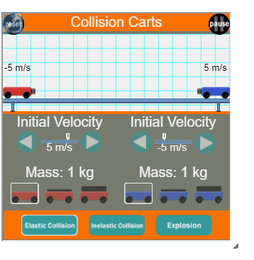
M₁:1kg
M₂: 2kg

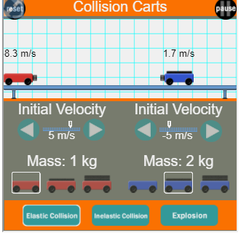

M₁:2kg
M₂: 3kg

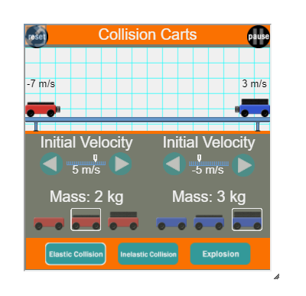
Initial velocity | Masses | Final velocity
5m/s | M₁:1kg | -5m/s
-5m/s | M₂: 1kg | 5m/s
5m/s | M₁:1kg | -8.3m/s
-5m/s | M₂:2kg | 1.7m/s
5m/s | M₁:2kg | -7m/s
-5m/s | M₂:3kg | 3m/s

Calculations and Error Analysis:

From law of conservation of momentum:
$\vec{F}$_{net}=0
Δ$\vec{p}$=0
$\vec{p}$=$\vec{p}$’
m₁$\vec{v}$₁+ m₂$\vec{v}$₂= m₁$\vec{v}’$₁₊ m₂$\vec{v}$’₂

where p – initial momentum,
p’ – final momentum,
v – initial velocity,
v’ – final velocity.

Initial velocity | Masses | Final velocity | Initial Momentum=$\vec{p}$  m₁$\vec{v}$₁+ m₂$\vec{v}$₂ | Final momentum =$\vec{p}'$  m₁$\vec{v}’$₁₊ m₂$\vec{v}$’₂ | $$\vec{p}-\vec{p}$$
5m/s | M₁:1kg | -5m/s | 5*1 + -5*1 =  0 kg•m/s | -5*1 + 5*1 =  0 kg•m/s | 0
-5m/s | M₂: 1kg | 5m/s | 5*1 + -5*1 =  0 kg•m/s | -5*1 + 5*1 =  0 kg•m/s | 0
5m/s | M₁:1kg | -8.3m/s | 5*1 + -5*2 =  -5 kg•m/s | -8.3*1 + 1.7*2 = -5 kg•m/s | 0
-5m/s | M₂:2kg | 1.7m/s | 5*1 + -5*2 =  -5 kg•m/s | -8.3*1 + 1.7*2 = -5 kg•m/s | 0
5m/s | M₁:2kg | -7m/s | 5*2 + -5*3 =  -5 kg•m/s | -7*2 + 3*3=  -5 kg•m/s | 0
-5m/s | M₂:3kg | 3m/s | 5*2 + -5*3 =  -5 kg•m/s | -7*2 + 3*3=  -5 kg•m/s | 0

% difference = 0%
Conclusion:
The experiment was conducted with success and the objective achieved. It was determined that indeed elastic collisions obey the law of conservation of momentum evident by the total momentum before collisions being equal to total energy after collision. Percentage difference was also found to be zero which shows consistency in our experiment.

